Use of ‘alerts’ for Pharmacogenomics Information

Interim evidence synthesis and outputs from the focus group meeting 19 September 2019

Draft Report

Document Management
This Focus Group Report (FGR) is an interim deliverable that presents the key themes emergent from the multi-disciplinary focus group meeting and early evidence synthesis that has taken place in phase one of the project (the scoping phase).

It aims to provide output data that will both inform the scope of the project (e.g. which tests, which medications, which prescribing environments the guidance will apply to) and to define an ‘alert’. The FGR provides an interim source of findings for the project team and project board and will help to inform future deliverables. This document will also set out a proposed scope to be tested during the remainder of this phase with the project stakeholders.
Revision History
Version | Date | Summary of Changes
0.1 | 23.09.2019 | First draft created by James Critchlow
0.2 | 27.09.2019 | Updated with comments from Sarah Jackson
0.3 | 03.10.2019 | Updated with comments from Reecha Sofat
0.4 | 11.10.2019 | Updated with comments from Afzal Chaudhry

Glossary of Terms

Term / Abbreviation | What it stands for
ADR | Adverse Drug Reaction
AHP | Allied Health Professions
API | Application Programming Interface
CDS | Clinical Decision Support
CPIC | Clinical Pharmacogenetics Consortium
CPOE | Computerised Physician Order Entry
DDI | Drug-drug interaction
DGA | Drug-gene association
DPWG | Dutch Pharmacogenetics Working Group
eMERGE | Electronic Medical Records and Genomics
EPR | Electronic patient records / Electronic health records
FDA | U.S Food and Drug Administration
FGR | Focus Group Report
FHIR | Fast Healthcare Interoperability Resources
GP | General Practitioner
MeSH | Medical Subject Heading
NHS | National Health Service
PGx | Pharmacogenomic
PRSB | Professional Record Standards Body for health and social care
RCT | Randomised Controlled Trial
SNP | Single Nucleotide Polymorphisms
TPMT | Thiopurine-S-Methyltransferase
USA | United States of America
WGS | Whole Genome Sequencing

CONTENTS:
- Executive summary
  - Introduction
  - Key Findings
  - Proposed scope
  - Next Steps
- Background
2.1 Pharmacogenomics 101
2.2 Synopsis: Evidence Synthesis
- Methodology
3.1 Overview
3.2 Sessions and participants
3.3 The questions
- Results

4.1 Summary of findings

4.2 Justification of findings
- Conclusion and next steps
- Appendices

1. Executive summary
1.1 Introduction
NHS England (NHSE) has commissioned the Professional Record Standards Body (PRSB) to develop practical guidance for prescribers regarding the implementation of pharmacogenomic (PGx) alerts or notifications across different systems and settings. The project will have three phases: scoping; development of the guidance and validation using clinical scenarios. This report is an interim report for phase 1, the scoping phase. The report will inform the scope for the guidance.
The scoping phase involves an evidence synthesis, a focus group meeting and individual stakeholder meetings. At the time of writing, the evidence synthesis is nearing completion and the focus group meeting has taken place. As part of the overall consultation process for stakeholder engagement and communications, PRSB is planning a total of three focus group meetings (one during each phase). The first focus group aimed to start to explore several themes with a view to informing the scope of the project (e.g. when, where, and to whom they should occur) and to define an ‘alert’ in this context.
1.2 Key Findings
Alerts should be triggered:
- in situations where pre-emptive sequencing or genotyping of the patient’s genome reveals a specific actionable drug-gene association (DGA) that would change prescribing behaviour.
- in situations where there is clear guidance available, that would be likely to change the prescriber’s choice of prescribed drug at the point of prescription order entry or when a patient’s PGx test results first become available in order to trigger a review of a patient’s current medications.

Guidance should be developed for alerts:
- that are active (interruptive) and post-test (follow the results of pre-emptive sequencing or genotyping)
- that takes active steps to mitigate potential unintended consequences such as alert fatigue
- that ensures that the information shared in an alert is succinct and can be readily actioned by prescribers and explained to patients

Guidance could be developed for alerts:
- that prompt an order for reactive genotyping and are therefore pre-test alerts.

Alerts should be seen:
- in multiple settings (primary and secondary care) and points in the prescribing process, by any healthcare professional involved in the patient’s care.
- during the prescribing process, even if the alert has been previously overridden by another healthcare professional.

PGx data for alerts should be stored in such a way:
- as to reflect the variable nature of PGx data (findings, significance, consequence etc) which may change as data is iteratively analysed.
- as to be amenable to open standards based interoperable communication and clinical decision support.

Alerts should not:
- place an undue burden on prescribers or patients.
- take the place of a formal result.

1.3 Proposed scope

Based on the key findings from the literature and the focus group meeting, the draft scope of the guidance for alerts is set out below. This will evolve during this phase of work as further meetings with stakeholders take place and additional evidence is reviewed.

The guidance will set out:

- The conditions that need to be met to trigger an alert, for example, the drug-gene pair must have an actionable result, or a pharmacogenomics test is mandatory. It will cover both pre and post-test alerts.

- What information needs to be shared in the alert. This may vary by professional. This could include information on the drug-gene pair, the action to be taken, where to go for further guidance etc.

- What guidance/information resources currently exist to provide further information on the prescribing recommendations.

- How the relative importance of the alerts should be categorised.

- The possible responses to a pharmacogenomic alert – for example, can the alert be overridden?

- Which professionals need to be alerted, under what conditions and when in the clinical process. The guidance will cover alerts in both primary and secondary care. The guidance will cover all professionals involved in prescribing and medicines reconciliation.

- Whether professionals who administer and dispense medications should receive alerts or have access to pharmacogenomic information and if so under what conditions and when in the clinical process.

- The potential benefits and impacts of the alerts on patients and any recommendations to optimise the benefits and mitigate the impacts e.g. queries by professionals about unusual doses etc.

- The potential benefits and impacts of alerts on the professionals and any recommendations to optimise the benefits and mitigate the impact e.g. alert fatigue.

The following will not be covered in the guidance:

- Where and how the Pharmacogenomics information should be stored e.g. whether it should be stored in central or local systems, whether and how it should be stored in Electronic Patient Record (EPR) systems.

- How the guidance for alerts or notifications should be implemented in EPR systems, clinical decision support systems (including e-prescribing systems)

- How the alerts should be presented, with the exception of potential recommendations in relation to mitigating unintended consequences, for example, alert fatigue. The presentation of alerts will be for local decision and will be constrained by the clinical systems in place.

1.4 Next Steps
The findings of this report will be combined with those of the final evidence synthesis and other stakeholder discussions in order to draft the project scope.
2. Background
2.1 Pharmacogenomics
Pythagoras noted around 510 BC that ingestion of the beans of fava plants resulted in a serious adverse reaction, but only in some individuals.(1) His insight that this could be explained by some kind of variation between people, is often considered to be the historical origin of pharmacogenomics.(2)

Today it is understood that the aetiology of this response is genetic. The most common form of genetic variation is single nucleotide polymorphisms (SNPs) where in each case a single nucleotide is found to be substituted in a gene when compared to a reference genome.(3) As a consequence of the central dogma of molecular biology, SNP variants will alter the structure and function of certain proteins. Consequently, SNPs in genes influencing how a drug is handled by the body can lead to unwanted effects, such as impaired efficacy and adverse drug reactions (ADRs).(4) A major aim of pharmacogenomics (PGx) is to identify these ‘actionable’ drug-gene associations (DGAs) to improve patient safety and clinical outcomes.

2.2 Synopsis: Evidence synthesis

Theme 1: What information is being ‘alerted’?

- Alerts and notifications reported in the literature are designed to share information about commonly studied actionable drug-gene associations.

- Prescriber buy-in to these alerts systems is optimised where simple and prescriptive testing recommendations are given, but the FDA only provide this for three of the most commonly alerted DGAs.

Clinical Decision Support (CDS) systems are used in health and care to support decision-making, The literature describes their use in pharmacogenomics as a rule-engine approach to process genotype data into actionable prescribing recommendations based on a patient’s genotype.(5) These recommendations can then be delivered to the end-user (prescriber) by different means, including alerts and notifications.(5) A 2018 study in the USA that analysed the implementation of PGx alerts within CDS systems in seven sites across the multicentre eMERGE Network found that the most commonly alerted DGAs in adults were clopidogrel (CYP2C19), simvastatin (SLCO1B1) and warfarin (CYP2C9, VKORC), whereas in children these were codeine (CYP2D6), oxycodone (CYP2D6), hydrocodone (CYP2D6) and tramadol (CYP2D6).(6) These well-studied associations generally result in the commonest and most predictable category of ADRs, type A, which are caused by the known pharmacology of a drug and tend to have high morbidity but low mortality.(7) Type B ADRs occur less commonly, are generally due to a type IV hypersensitivity reaction and are associated with low morbidity and high mortality.(7) Type B ADRs are associated with some of the best characterised DGAs including allopurinol (HLA-B*5801), dapsone (HLA-B*1301), abacavir (HLA-B*5701), and carbamazepine (HLA-B*152).(8)

With the exceptions of oxycodone (CYP2D6) and allopurinol (HLA-B*5801), all the DGAs listed above are labelled by the FDA as having actionable PGx. However, abacavir (HLA-B*5701) and carbamazepine (HLA-B*152) are the only two DGAs where testing is FDA mandated (in order to avoid abacavir hypersensitivity syndrome in HIV positive patients and carbamazepine related Stevens-Johnson syndrome in South East Asians, respectively).(8) When clinical guidance with a solid evidence base is prescriptive in this way, then rates of clinical adoption and prescriber ‘buy-in’ to the alert systems are optimised.(9) However, there is a paucity of high quality clinical evidence (RCTs) to demonstrate clear benefits of PGx testing.(9) The majority of these common DGAs have limited or absent FDA guidance. This is despite significant safety and efficacy benefits of PGx testing in some cases (e.g. warfarin, clopidogrel) and ‘significant evidence supporting a known pharmacogenomic risk’ in others (e.g. allopurinol).(9)

There are at least 319 actionable DGAs described comprising of at least 204 drugs and 87 genes (appendix 1).(10) Of the approximately 1,200 FDA approved drugs an estimated 7% have clinically actionable DGAs, which make up an estimated 18% of all annual prescriptions in the United States.(4) A recent study in the Netherlands estimated that, for the 45 most commonly prescribed drugs in primary care, 23.6% of new prescriptions involved ‘actionable’ DGAs using Dutch Pharmacogenetics Working Group DPWG criteria.(11) However, this was estimated to translate into a change of drug or dose adjustment in 5.4% of new prescriptions.
Theme 2: How is the information presented?
- Currently the majority of pharmacogenomic alerts studied are active and post-test, often taking the form of electronic popup alerts.

- Alert fatigue is a major unintended consequence of alerts systems that can nullify the effectiveness of alerts and has significant consequences for patient safety.

The pharmacogenomic alerts described in the literature most often take the form of electronic popup alerts.(12, 13) In addition, they can also take the form of email notifications and text message alerts.(5) Alerts can be pre- or post-test (appendix 2). Post-test alerts are triggered in scenarios where patient PGx test results are known following pre-emptive sequencing or genotyping and there is a positive genotype for an actionable DGA.(6, 9) Pre-test alerts are triggered in scenarios where patient PGx test results are unknown and will usually prompt a prescriber to order reactive genotyping.(6, 9) Alerts come in either ‘active’ or ‘passive’ forms (appendix 2). Active alerts are interruptive (must be actioned to progress in the workflow) and appear during order entry, after a prescribing choice has been made.(6) Passive alerts are optional and generally appear somewhere in the EPR workflow, often providing links to additional guidance or interpretation of patient PGx data.(6) Currently the majority of PGx alerts are active, post-test, and contain specific prescribing recommendations.(6, 12, 13) Mechanisms of popup alert presentation are variable but usually contain static text to convey information regarding the reason for and relative importance of the alert, a summary of the relevant DGA / phenotype, and a recommended course of action (appendix 1).(6, 9, 12, 13) There may also be ‘passive’ links to internally curated guidance or external sources.

Strategies to mitigate the unintended consequences of alerts are commonly discussed in the literature. In particular, alert fatigue, is a desensitisation phenomenon that occurs when CDS systems are utilised in live clinical settings.(14) As the majority of alerts seen by a prescriber are of limited clinical consequence the sheer number of daily notifications results in users ignoring or overriding the alert.(14) There are significant safety implications associated with alert fatigue. A retrospective study from the USA analysed prescriber-patient interactions where a CDS system alerted co-prescription of opioids (211,000 visits) and benzodiazepines (85,000 visits).(15) Data was collected over one year (six months pre-intervention, six months active intervention). The alerts were found to have minimal effect on prescribing behaviour. This was taken to illustrate the importance of minimising alert fatigue with careful consideration of alert characteristics.

There is increasing interest in the development and adoption of features to minimise alert fatigue. A 2009 retrospective study in the USA attempted to validate one strategy for mitigating alert fatigue caused by drug-drug interaction (DDI) alerts.(16) The authors compared a priority ‘tiering’ method (39,474 alerts) with a control (31,876 alerts), conducted at different sites. Under the tiering strategy only identified high-risk DDIs were actively alerted - low-risk DDIs were alerted passively. They found that the number of severe alerts overridden at the tiered site (0%) was far less than the non-tiered site (66%). This suggests a significant reduction in alert fatigue for clinically important safety alerts.
Theme 3: How is the information available dynamically through the life-cycle of a prescription?
- Alerts are generally triggered at the time a prescription is written but may occur at other times, in a variety of clinical settings and to a number of health professionals.
PGx alerts have been evaluated or considered for several different clinical settings within primary (appendix 3) and secondary care (appendix 4). Alerts are generally triggered at the time a prescription is written, at the point of order entry, such as when a high-risk drug is prescribed with a known actionable DGA. Some CDS systems also present an additional alert to a pharmacist at the verification and dispensing stage of a prescriptions ‘life-cycle’.
An interesting but currently theoretical setting for PGx alerts is the perioperative period. A group at the University of California San Diego have outlined a framework for how this might be done (appendix 5).(17) The authors suggest that alerts should be triggered at multiple points; first in the preoperative period when PGx test results first become available, later at the point of order entry for postoperative prescriptions, and possibly even during the surgery itself. However, how this will work within a broader framework is uncertain.
Theme 4: How is this going to iteratively evolve?
- Ideally a person will only have to undergo one pharmacogenomic test in a lifetime following whole genome sequencing or genotyping.
- This will require iterative analysis over many years and the solving of several data processing and storage challenges that are today unresolved in the literature.
Attempts to integrate PGx data into the current EPR systems have been made but are in their infancy. Early solutions have involved placing a patient’s known DGAs within the problem list or allergy list (specifically in the case of abacavir (HLA-B*5701)).(9) However it is an open question whether PGx data deserves its own ‘unique repository’ within the EPR, in future CDS systems.(9)
Another challenge is ensuring that the implementation of PGx alert systems is futureproof and remains so for both discovery and delivery aspects. The topic of which data format to use as standard is controversial.(5) Raw PGx data undergoes several iterations of processing before it can be interpreted by an end-user. It is likely that individual patient’s PGx data will need to be reprocessed through new pipelines as sequencing or genotyping technology improves or when guidelines are updated, in order for the rule-engine underlying the alerts to function correctly.(5) As technology improves, re-analysis of old data may also be a fruitful source of new variant discovery. Finding the right balance between maintaining high quality data for variant discovery and further processed but more actionable data formats is currently an unresolved issue in the literature.
3. Methodology
The overall approach to the development of the guidance is phased.

The first phase is the scoping phase which consists of:
- an evidence review and synthesis
- a focus group meeting with a small number of key stakeholders
- individual interviews with other key stakeholders (including country comparator opinion leaders) and attendance at existing network meetings to test the scope.

The second phase is the development of guidance and this will consist of:
- further individual stakeholder meetings and use of existing networks and meetings to test the guidance including the PRSB Advisory Board meeting
- a second wider multi-disciplinary and patient focus group meeting to test and refine the guidance.

The third phase is validation of the guidance. This will include:
- validation and testing using real-life clinical scenarios.
- a final focus group will take place to review the findings of the validation exercise and refine the guidance.

The first focus group meeting took place on the 19/09/2019. The aim of this focus group meeting was to start to explore what the scope of pharmacogenomic alerts guidance should be in order to improve safety and care of patients. In this session facilitators sought the opinions of participants in relation to one of four key themes relating to pharmacogenomic alerts. This was done using a PowerPoint® presentation illustrating some common themes from the evidence synthesis, interspersed with a series of ‘prompt’ questions as a starting point. The proceedings were recorded, and the outputs analysed in order to refine and revise the scope in the light of the focus group meeting.
The scope of the literature review for the evidence synthesis was necessarily limited in scope by time and budget constraints. A systematic yet pragmatic approach was used. 10 well-known articles were initially used as key studies. Citation chaining was done on these articles to identify further papers using Google Scholar®. In addition, a mini-search-strategy was performed on the Medline bibliographic database using PubMed. This included controlled vocabulary (MeSH terms) and key words linked by boolean operators (appendix 8). The 293 articles identified were then excluded/included by title and abstract. Inclusion criteria were articles relevant to the previously identified four key themes.

3.2 Sessions and participants
Sessions
- Phase 1 focus group meeting to start to explore the scope of the guidance - completed
- Phase 2 wider focus group meeting to review the draft guidance - TBC
- Phase 3 focus group meeting to review the output of clinical validation - TBC

Participants
Attendee name | Title / Responsibility
Sarah Jackson | PRSB Project Manager
Dr Afzal Chaudhry | PRSB Vice Chair, CMIO Cambridge University Hospitals NHS FT, Renal Physician
Jane Gregson | NHS England, National Head of Genomics Informatics
Dr Reecha Sofat | Clinical Lead, Associate Professor Institute of Health Informatics, University College London  Consultant Clinical Pharmacology, GIM and Stroke UCLH Foundation Trust
Stephen Goundrey-Smith | Royal Pharmaceutical Society, Consultant and Informatician
Sonali Sanghvi | Genomics Unit at NHS England, Pharmacy Adviser
Helene Feger | PRSB, Director of Strategy, Communications and Engagement
Alannah McGovern | PRSB, Membership Manager
Dr Ian Thompson | Clinical Informatics Specialist, eHealth Clinical Advisor (Primary Care) and GP in Scotland
Vashti Ragoonanan | Clinical Nurse Specialist (Haematology), London North West Healthcare NHS Trust
Prof Bill Newman | Clinical Head of Division in Genomic Medicine, Manchester University NHS Foundation Trust
Richard Pugmire | Genomics Unit at NHS England
Dr John-Paul Carter | Project Research and Analysis, Institute of Health Informatics, University College London
James Critchlow | Project Research and Analysis, Institute of Health Informatics, University College London
3.3 The questions
Theme 1: What are you going to alert about?
- What information should be required to trigger an alert?
Theme 2: How is the information presented?
- Should we be developing guidance for both pre-test and post-test alerts?
- What information should be shared in an alert?
- How can we ensure that the information shared is actionable and is actioned? (Are there any barriers to implementing alerts in your practice?)
Theme 3: How is the information available dynamically through the life-cycle of a prescription?
- Who do we want to alert?
- When in the clinical process do we want to alert them?
- In what clinical settings should alerts occur?
Theme 4: How is this going to iteratively evolve?
- As new evidence comes to light, how should alerts be updated?
- Overall, given what has been implemented elsewhere, how would we want to implement this in England?
- We want to involve patients – how and when do we do this?
4. Results

4.1 Summary of findings
Alerts should be triggered:
- where it is clinically relevant to the patient concerned.
- where it will change the prescriber’s choice of action.
- where there is patient data available with a positive phenotype.
- where there is patient data available with an actionable DGA.
- where guidance is available describing a clearly defined intervention.
- where there is a prescribing contraindication in the context of a known DGA.
- in a context where obtaining the results of an appropriate PGx test is practicable (post-test alerts).
- in a context where a clearly defined intervention in response is practicable.
- at the point of prescription order entry.
- at the point when a patient’s PGx test results first become available.

Alerts could be triggered:
- where there is clinical equipoise over the efficacy of testing for a particular DGA.
- where patient data is unavailable relating to an actionable DGA.
- at multiple points throughout the lifecycle of a prescription, including the points of order entry, administration and dispensing.
- in situations where PGx testing is mandatory (pre-test alerts)
- in a context where ordering an appropriate PGx test is practicable (pre-test alerts)

Guidance should be developed for alerts:
- that follow pre-emptive sequencing and are therefore post-test alerts.
- that are resistant to unintended consequences such as alert fatigue.
- that prompt a medication review or review of the patient following new actionable PGx results becoming available.

Guidance could be developed for alerts:
- that prompt an order for reactive genotyping and are therefore pre-test alerts.

Alerts should share:
- succinct information regarding the PGx variant e.g. a straightforward summary
- specific information about the action required e.g. a calculated dose reduction
- information that is readily explainable to patients.

Alerts could share:
- a passive external link to more detailed background information / further guidance.
- information justifying previously actioned alerts with health professionals downstream in the prescription cycle e.g. why a particular dose reduction occurred.

Alerts should be seen:
- by any healthcare professional (including AHPs) who is responsible for the care of a patient for whom the alert portends.
- by any healthcare professional (including AHPs) during the prescribing process and with a duty of care, even if the alert has been previously overridden by another healthcare professional.
- in multiple settings, including those in primary care, secondary care and community pharmacies.

Alerts could be seen:
- by carers in care homes or the community who have a duty of care and may be trained to administer prescription medications.
- in other settings, including those in tertiary care.

PGx data for alerts should be stored in such a way:
- that it enables an alert to be triggered in line with the developed guidance.
- as to reflect the variable nature of PGx data (findings, significance, consequence etc) which may change as data is iteratively analysed.
- as to be amenable to open standards based interoperable communication and clinical decision support.

Alerts should not:
- place an undue burden on prescribers or patients such that their experience of day-to-day clinical practice is significantly disrupted.
- take the place of a formal result, although a link to this should be provided.

4.2 Justification of findings
Key findings | Illustrative quotes | Literature review
Alerts should be triggered:

- in situations where pre-emptive sequencing or genotyping of the patient’s genome shows a positive phenotype for a specific actionable drug-gene association (DGA) (post-test alerts). | - “there are a lot of alerts in prescribing and having one which is clinically and specifically actionable is key.” | - This finding represents a clear consensus within the focus group. An estimated 7% of the approximately 1,200 FDA approved drugs have ‘actionable’ DGAs. (4) However, clinical adoption of CDS systems and alerts is known be easier when well characterised DGAs, such as abacavir (HLA-B*5701) for the treatment of HIV, are alerted.(8, 9)
- in situations where there is clear guidance available, that would be likely to change the prescriber’s choice of action, to a clearly defined intervention that is practicable. | - “There’s no point in alerting a prescriber or dispenser if they can’t do anything about it? Where clear intervention could take place and clear guidance on what should be done. Some drugs guidance says to reduce the dose but does not say by how much – clear guidance for prescribers is necessary.” | - The most commonly alerted ‘actionable’ DGAs in the literature are mostly considered actionable by the FDA and have guidance available from sources such as CPIC and DPWG, but limited or absent FDA guidance.(5) This is despite the fact that in many cases the benefits of PGx testing, or the risks of not, are known to be significant.(5)
- at the point of prescription order entry or when a patient’s PGx test results first become available in order to trigger a review of a patient’s current medications. | - “When a result is made available somebody should be actioning that – to see implications of that result on a patients care – a meds review at the very least…There is potential unintended consequence of increased workload for the prescriber if anyone downstream queries why they ignored an alert.” | - This was done in one CDS system utilised in the USA where “…emails are sent to each affected patient’s primary physician and nurse practitioner when high-risk phenotypes are added to the problem list [automatically following a lab test result].”(12)
Guidance should be developed for alerts:

- that are active (interruptive) and post-test (follow the results of pre-emptive sequencing). | - “At the moment we focus on post-test alerts but recognise that pre-test might be needed down the line.” | - A multicentre analysis in the USA suggests that the majority of alerts are active, post test, and contain specific prescribing recommendations for the end-user. (6) This supports the focus group’s clear decision to include post-test alerts in the scope.
- that takes active steps to mitigate potential unintended consequences such as alert fatigue. | - “The challenge of alert fatigue is because people haven’t gone through this process – establishing the principles that we are trying to.” “making alert relevant to the prescriber makes the fatigue go away” | - A new retrospective study has demonstrated clearly the detrimental impact of alert fatigue on alert effectiveness and safety. (15). A previous study had found that a lack of ‘tiering’ where “less serious [alerts] [are] presented in a non-interruptive [passive]” way, was associated with increased overriding of alerts with more severe content.(16)
- that ensures that the information shared in an alert is succinct and readily explainable to patients. | - “We would want to be in a position to advise patients at the stage of community pharmacy.” | - The need for clarity is well recognised amongst the evidence base.(9) The need for alerts to be “concise” and “as simple as possible” was expressed by respondents in one study.(13)
Alerts should be seen:

- in multiple settings (primary and secondary care) and points in the prescribing process, by any healthcare professional involved in the patient’s care. | - “…when you’re the prescriber you might park a decision to one side. Someone down the line will pick it up – usually a pharmacist. These alerts might have to appear at multiple points to ensure safety.” | - Most alerts in CDS systems are shown at order entry. (6) In a 2014 study of pre-test alerts in secondary care in the USA the majority of alerts were shown to attending physicians, nurse practitioners and pharmacists. (12) These were presented when “during prescribing or to pharmacists when the orders were processed for dispensing.”
- during the prescribing process, even if the alert has been previously overridden by another healthcare professional. | - “Any healthcare professional that has a responsibility and duty to patient, they need to see that information even if the GP has chosen to override that.” | - It is unclear at this point if this issue has been discussed in the literature.
PGx data for alerts should be stored:

- in such a way as to reflect the variable nature of PGx data (findings, significance, consequence etc) which may change as data is iteratively analysed.  - in such a way as to be amenable to open standards based interoperable communication and clinical decision support. | - “The data should be stored in a way that can be iteratively analysed.”  - “I would be cautious of trying to shoehorn this in the problems or allergies list.” | - With adequate storage capacity PGx testing should only need to be done “once in a lifetime.”(9) However, “[s]ignificant updates [of the PGx evidence / guidance or the CDS system software] might sometimes require the pre-processing and analysis workflow to be rerun in order to produce more accurate results in the downstream analysis. “(5) This concept seemed to be well recognised amongst the group.  - Early attempts to integrate PGx into the EPR have stored PGx data either in the allergy or problem lists.(9) For example, guidelines in the USA state that the DGA of abacavir (HLA-B*5701) should “be recorded as an abacavir allergy in the patient’s medical record.”(18) However, it is recognised that this was done in order to integrate PGx with existing EPR systems and that other solutions e.g. “ancillary [systems] that interface with the [EPR] will be required [in future].”(18)
Alerts should not:
- place an undue burden on prescribers or patients. | - “Are we placing a burden on prescribers which may make day to day practice impossible?” | - The burden of “too many warnings” on prescribers results in alert fatigue with demonstrable safety implications for patients in real life clinical settings. (14)
- take the place of a formal result. | - “The alert is not designed to take place of formal result however it should still be linked to that detail.” | - PGx reports generally “consist of raw unstandardized, narrative interpretations…as pdf documents…” that are necessarily separate from the CDS rule-engine as they are “difficult to compute.” (17) In one USA study 52% of physicians (n=52) participating in an online simulation and questionnaire responded that PGx alerts should provide “a link to the patient’s genetic lab report.” (13)

Other findings | Illustrative quotes | Literature review
Alerts could be triggered:

- where there is clinical equipoise over the efficacy of testing for a particular DGA (pre-test alerts). | - “There are different levels of evidence and some drug-gene pairs are more established than some others…that have clinical equipoise…there is more granularity in those relationships.” | - Of the most commonly alerted ‘actionable’ DGAs in the literature, only two are mandated and one recommended (thiopurines with TPMT) by the FDA for pre-emptive testing.(8) It was acknowledged in the focus group that alerts for other DGAs would have greater complexity.
- where patient data is unavailable relating to an actionable DGA (pre-test alert). | - “We want to focus on post-test alerts. bearing in mind that we might have to systemically look at pre-test/ drug gene panels when we receive that information. “ | - A 2014 USA study did issue pre-test alerts in secondary care “when a very-high risk medication [was] prescribed” such as codeine. However, pre-test alerts are less common in CDS systems.(6) This is in line with the decision of the focus group to concentrate on post-test alerts.
- at multiple points throughout the lifecycle of a prescription. | - “…different people might need to see different things and talk to the different professionals involved at different stages….” | - Most alerts in CDS systems are shown at order entry.(6) Some studies also trigger alerts at the dispensing stage.(12)
- in situations where pharmacogenomics testing is mandatory (pre-test alerts) | - “…some of the pharmacogenomics are more mature than others. Testing is mandated with some pairs – there are red lights that need to be flagged…” | - Abacavir (HLA-B*5701), and carbamazepine (HLA-B*152) are FDA mandated for pre-emptive PGx testing and therefore “…clinical adoption follows with minimal or no resistance.”(9)
Guidance could be developed for alerts:

- that prompt an order for reactive genotyping and are therefore pre-test alerts. | - “At the moment we focus on post-test alerts but recognise that pre-test might be needed down the line.” | - Pre-test alerts are less common in CDS systems.(6) This is in line with the decision of the focus group to concentrate on post-test alerts.
Alerts could share:

- a passive external link to more detailed background information / further guidance. | - “– a further link to background info is a good idea but I’m not sure how well systems will be able to do that.” | - Alerts trialled in other countries often provide external links to more detailed guidance or background. (9, 12) A USA study involving online simulation and questionnaire found that 80% of physicians (n=52) participating found such links useful.(13)
- information justifying previously actioned alerts with health professionals downstream in the prescription cycle e.g. why a particular dose reduction occurred. | - “information explaining why a dose reduction has occurred may be useful for other professionals such as the pharmacist and / or nurse.” | - It is unclear at this point if this issue has been discussed in the literature.
Alerts could be seen:

- by carers in care homes or the community who have a duty of care and may be trained to administer prescription medications. | - “In my experience of carers, they would be reluctant to administer the drugs without written guidance…there is a difference between those working in a care home and in the community. They have different responsibilities.” | - It is unclear at this point if this issue has been discussed in the literature.
- in other settings, including those in tertiary care. | - “With carers there is a danger that carers will panic and delay or withhold medication.” | - It is unclear at this point if this issue has been discussed in the literature.

5. Conclusion and next steps

This focus group meeting was prompted throughout by themes from the evidence synthesis and a certain amount of congruence was found with the extant literature, and this was to be expected. However, a number of novel insights were gained that can be used to generate guidance for pharmacogenomic alerts as well as further themes for discussion during the forthcoming consultations with country comparator opinion leaders. Furthermore, there seemed to be a consensus in several areas including: i) that the scope of this work should be limited to post-test alerts at this stage ii) that alerts should prompt a clearly defined action that is practicable in the local setting iii) that alerts should be seen by multiple health care professionals at multiple stages of the prescription life cycle, in both primary and secondary care iv) that patients should have an opportunity to express their opinion on the forthcoming guidance and that the information shared in an alert should be readily explainable to them. Significant areas of disagreement were not identified but may have become more apparent if there was more time available for discussion.

Next steps to include:

- Finalisation of the secondary evidence synthesis
- Development of a brief questionnaire and introductory email for out of country comparators
- Initiation of contact with stakeholders and out of country comparator opinion leaders by email and the scheduling of telephone interviews
- Incorporation of insights from evidence synthesis and primary research into a final scoping paper for review by the initial focus group participants and other key stakeholders and approval by the project board.
- This will be followed by the development and validation of the guidance itself.

6.1 Appendices

Appendix 1 – DGAs with guidance available
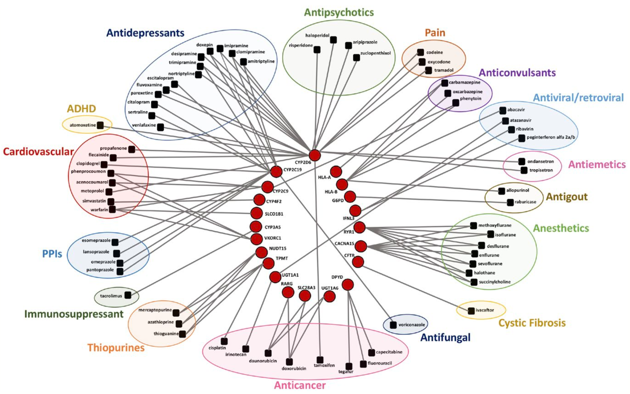

Reproduced from Bousman et al. 2019

Appendix 2 – Example of an alert
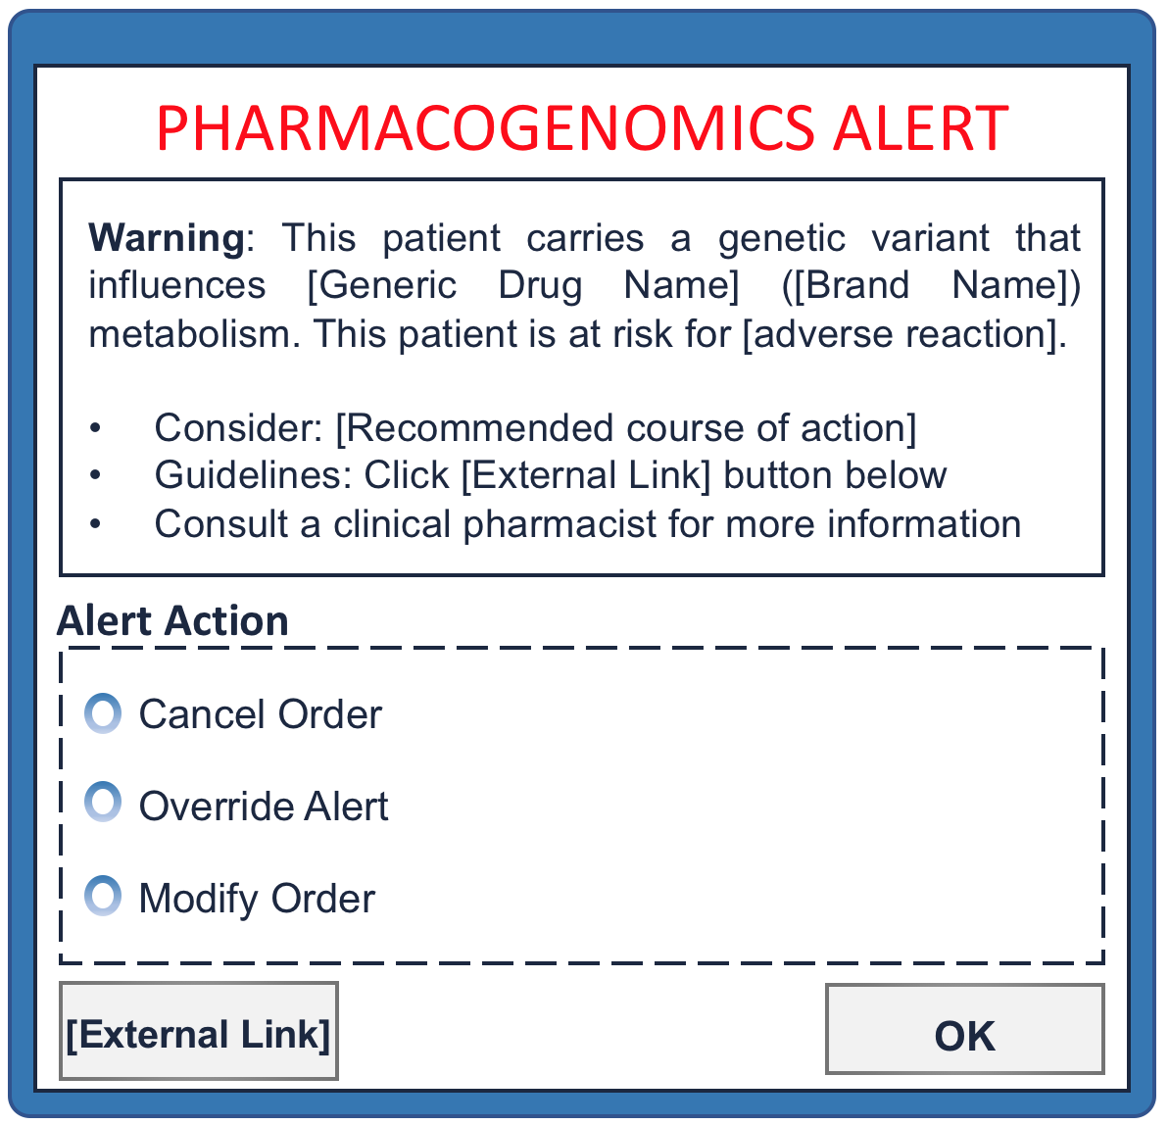

Appendix 3 – Alert flow diagram

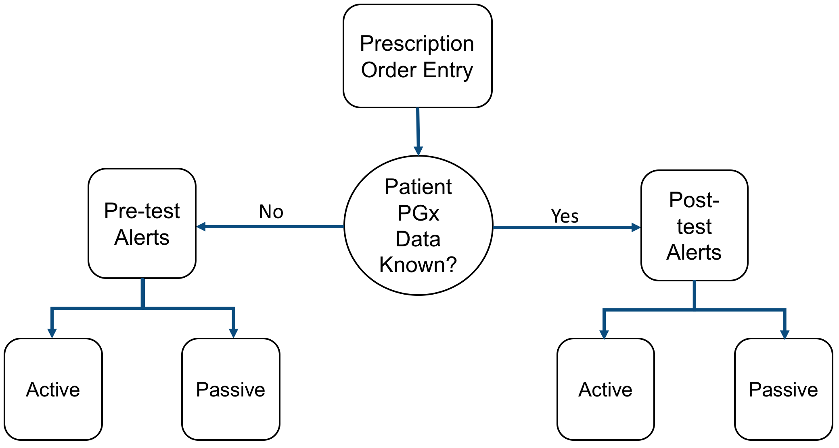

Appendix 4 – Life cycle of a prescription in primary care
This diagram is currently being revised.
Appendix 5 – Life cycle of a prescription in secondary care
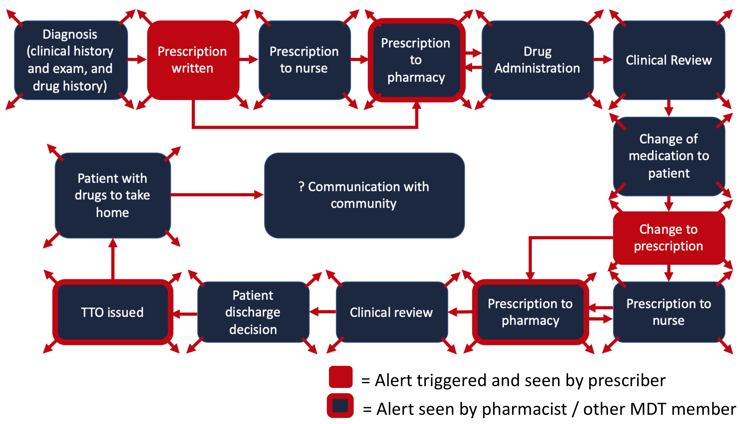

Appendix 6 – Potential use of PGx alerts in the perioperative period
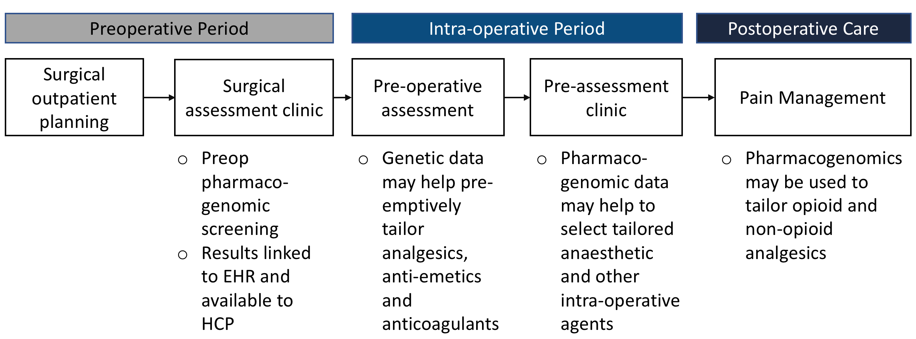

Adapted from Ohno-Machado et al. 2018

Appendix 7 – Pharmacogenomic Landscape
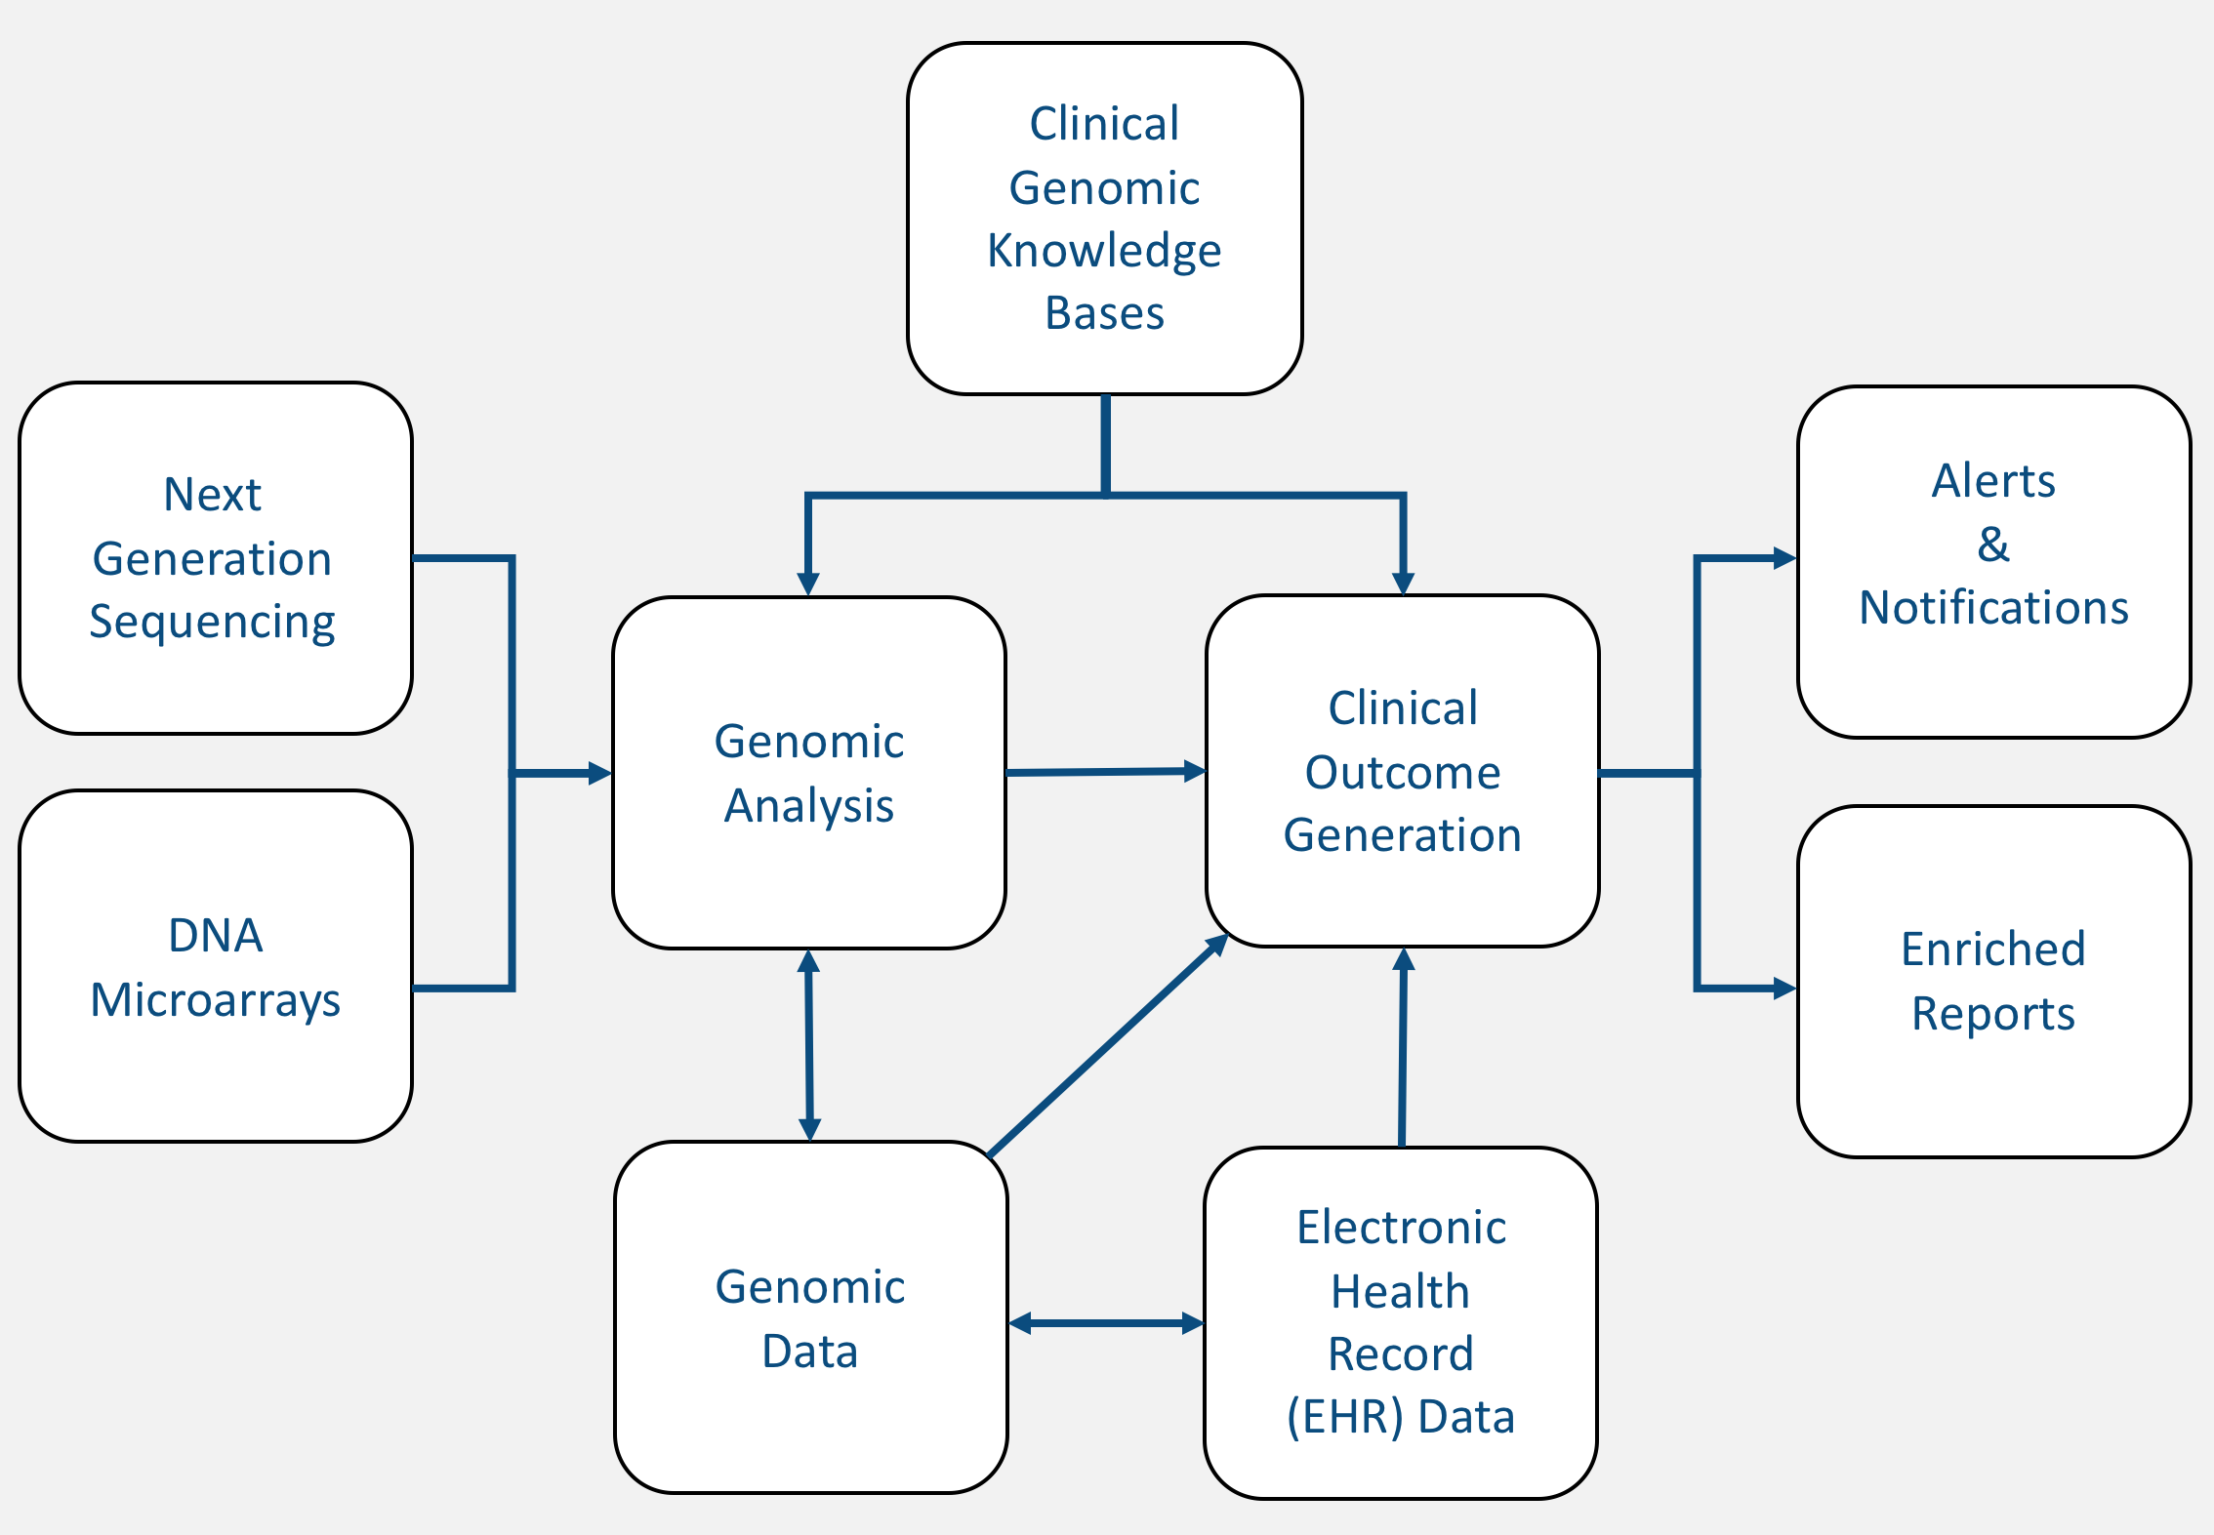
Adapted from Kawam et al. 2018

Appendix 8 – Primary mini-search strategy
(("Pharmacogenomic Variants"[Mesh] OR "Pharmacogenomic Testing"[Mesh] OR "Pharmacogenetics"[Mesh] OR "Precision Medicine"[Mesh] OR pharmacogen*) AND ("Decision Support Systems, Clinical"[Mesh] OR "Medical Order Entry Systems"[Mesh] OR notification* OR “Computerised Physician Order Entry”[All Fields] OR alert*[All Fields])
Appendix 9 – References
1. Meletis K, Konstantopoulos K. Favism - from the “avoid fava beans” of Pythagoras to the present. Haema. 2004;7(1):17 - 21.
2. Pirmohamed M. Pharmacogenetics and pharmacogenomics. British Journal of Clinical Pharmacology. 2001;52:345 - 7.
3. What are single nucleotide polymorphisms (SNPs)? Online: U.S. National Library of Medicine; 2019 [Available from: https://ghr.nlm.nih.gov/primer/genomicresearch/snp.
4. Relling MV, Evans WE. Pharmacogenomics in the clinic. Nature. 2015;526(7573):343-50.
5. Al Kawam A, Sen A, Datta A, Dickey N. Understanding the Bioinformatics Challenges of Integrating Genomics into Healthcare. IEEE J Biomed Health Inform. 2018;22(5):1672-83.
6. Herr TM, Peterson JF, Rasmussen LV, Caraballo PJ, Peissig PL, Starren JB. Pharmacogenomic clinical decision support design and multi-site process outcomes analysis in the eMERGE Network. J Am Med Inform Assoc. 2019;26(2):143-8.
7. Kaufman G. Adverse drug reactions: classification, susceptibility and reporting. Nursing Standard. 2016;30(50):53 - 63.
8. Khan DA. Pharmacogenomics and adverse drug reactions: Primetime and not ready for primetime tests. J Allergy Clin Immunol. 2016;138(4):943-55.
9. Caraballo PJ, Bielinski SJ, St Sauver JL, Weinshilboum RM. Electronic Medical Record-Integrated Pharmacogenomics and Related Clinical Decision Support Concepts. Clin Pharmacol Ther. 2017;102(2):254-64.
10. Bousman CA, Zierhut H, Muller DJ. Navigating the Labyrinth of Pharmacogenetic Testing: A Guide to Test Selection. Clin Pharmacol Ther. 2019;106(2):309-12.
11. Bank PCD, Swen JJ, Guchelaar HJ. Estimated nationwide impact of implementing a preemptive pharmacogenetic panel approach to guide drug prescribing in primary care in The Netherlands. BMC Med. 2019;17(1):110.
12. Bell GC, Crews KR, Wilkinson MR, Haidar CE, Hicks JK, Baker DK, et al. Development and use of active clinical decision support for preemptive pharmacogenomics. J Am Med Inform Assoc. 2014;21(e1):e93-9.
13. Nishimura AA, Shirts BH, Salama J, Smith JW, Devine B, Tarczy-Hornoch P. Physician perspectives of CYP2C19 and clopidogrel drug-gene interaction active clinical decision support alerts. Int J Med Inform. 2016;86:117-25.
14. Carroll A. Averting alert fatigue to prevent adverse drug reactions. Journal of the American Medical Association. 2019;322(7):601.
15. Neprash H, Smith L, Golberstein E, Anderson K, Christiaansen T, Paterson N, et al. The Association of EHR Drug Safety Alerts and Co-prescribing of Opioids and Benzodiazepines. Journal of General Internal Medicine. 2019;34(8):1403 - 5.
16. Paterno MD, Maviglia SM, Gorman PN, Seger DL, Yoshida E, Seger AC, et al. Tiering drug-drug interaction alerts by severity increases compliance rates. J Am Med Inform Assoc. 2009;16(1):40-6.
17. Ohno-Machado L, Kim J, Gabriel RA, Kuo GM, Hogarth MA. Genomics and electronic health record systems. Hum Mol Genet. 2018;27(R1):R48-R55.
18. Martin MA, Hoffman JM, Freimuth RR, Klein TE, Dong BJ, Pirmohamed M, et al. Clinical Pharmacogenetics Implementation Consortium Guidelines for HLA-B Genotype and Abacavir Dosing: 2014 update. Clin Pharmacol Ther. 2014;95(5):499-500.

Further work is required on which professionals should see alerts and under what circumstances as part of the next stage. For example, work is required on what, if any, information should be shared during medication administration.
The discussion at the focus group meeting concluded that the guidance should cover post-test alerts. However, subsequent correspondence with NHS England requested that the guidance also considers pre-emptive alerts.

